Ladies Program
October 28, 2023
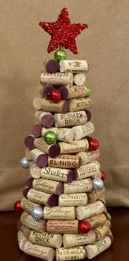
Come and enjoy the day with other Ladies at the Masonic Temple. All ladies are invited for the entire day or any part of the day.

8:00 - 9:00 Meet and greet in the 3rd floor lounge of the Masonic Temple. There will be light refreshments available.
9:00 - 11:30 Get ready for Christmas by making a tree out of wine corks! You can personalize it any way you like with an assortment of decorations. I will provide the hot glue and decorations. If you have a hot glue gun and would like to bring it that would be great. I do have several glue guns, but not enough for everyone to have one. Also if you have corks laying around that you would like to put to good use, please bring them. (The more corks we have the bigger the tree you can make.)
11:30 - 12:30 Lunch with the men in the small dining room downstairs.
12:30 - 3:00 Various activities will be available to everyone while socializing and enjoying the company of other ladies.
*All times are approximate.

Please come dressed casually. There will be time to change before the banquet’s social hour.
There will be no cost for the day's activities and lunch. Please reply if you are attending with your banquet reservation to make sure we have enough hot glue sticks.
Any questions feel free to contact me.

Gail Abernathy
715-523-1174
gabernathy1174@gmail.com

